**REPORT**

# Probability of Attrition

The probability of attrition is modeled in Python. The model correctly predicted 99% of the instances in the test set. The recall value showed that the model successfully identified 97.2% of the employees who are likely to leave. The precision of the model indicated that when the model predicts an employee will leave, it is correct 99.3% of the time. The Learning Curve demonstrated that both the training and validation loss curves converge to low values and remain stable, indicating that the model is well-trained.

# Data Analysis

Correlation matrix was created to see relationship between parameters. Although the correlations were small, variables that had a high correlation with turnover compared to other parameters were segmented. The relationships between the graphs were observed to see how multiple variables affected the turnover rate.

## A) Significant Variables

This section will give an overview of the significant variables that affect the turnover rate. For comparative purposes, the overall turnover rate was found to be 16%.

* **Age**: The younger the employee, the higher the likelihood of attrition. This rate decreases towards middle age and increases slightly with old age.

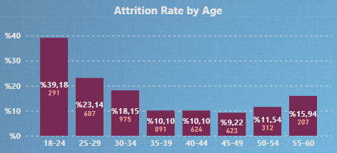

*Recommendation:* Targeted retention programs for younger employees, such as career development opportunities and mentorship programs, may help lower attrition rates among this demographic.

* **Business Travel:** As travel frequency increases, the attrition rate also increases. Frequent travelers have a 17% higher turnover rate than those who never travel.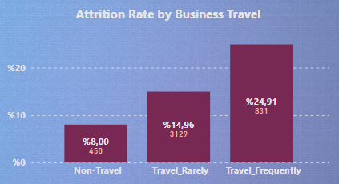

*Recommendation:* Employees who like to travel can be hired for positions that require travel. The frequency of travel can be decided together with the employee. Privileges may be given to employees who travel frequently.

* **Department**: The department an employee works in significantly affects attrition rates. The turnover rate in the HR department is 15% higher than other departments.

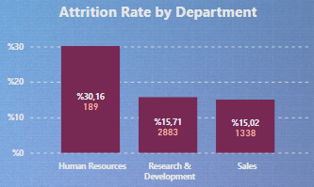

*Recommendation:* Focus can be made on the differences between working conditions in the HR department and other departments and improvements can be made in these matters.

* **Education Field**: The field of education is significantly related to attrition. HR has 26% higher attrition rate than average of others.

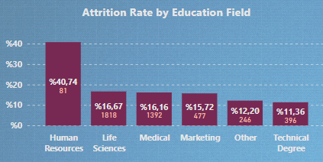

*Recommendation:* Providing support for further education and development opportunities could help reduce attrition rates.

* **Environment Satisfaction**: There is relation between lower environment satisfaction and higher attrition rate.

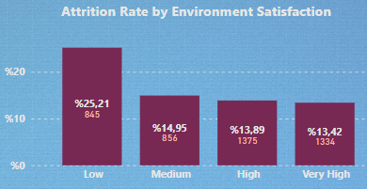

*Recommendation:* Investing in a positive work environment, conducting regular employee satisfaction surveys, and addressing any issues can lead to a more engaged and loyal workforce, reducing attrition.

* **Extra/Fewer Working Hours Per Day:** In this parameter, the average overtime or short working hours of the employees are examined according to the standard 8-hour daily working time on the days they work. It is observed that the turnover rate decreases by 6% in case of missing work for more than half an hour on average per day. The turnover rate of those who work more than half an hour on average per day increases.

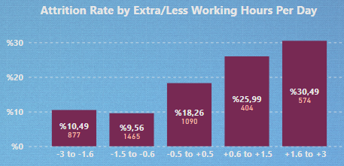

* **Job Satisfaction**: Employees who have low job satisfaction are more likely to leave.

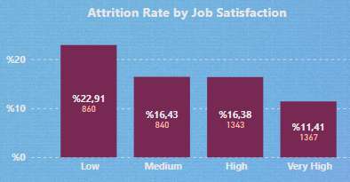

*Recommendation:* Enhancing job satisfaction through recognition programs, career advancement opportunities, and addressing role-specific concerns can significantly reduce employee attrition.

* **Marital Status**: The turnover rate of single people is approximately 14% higher than that of married and divorced people.

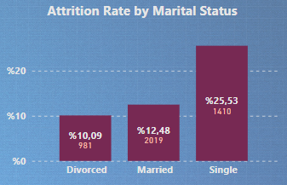

*Recommendation:* Offering flexible work arrangements and promoting work-life balance initiatives can support employees with different marital statuses, potentially reducing attrition.

* **Number of Companies Worked**: Employees who have worked at many companies are more likely to leave.

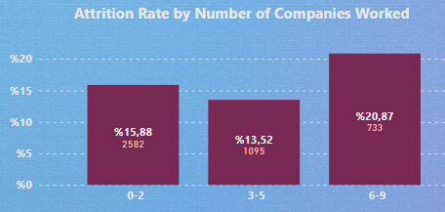

*Recommendation:* Creating a strong value proposition for staying with the company, especially for employees with diverse work histories, can help improve retention.

* **Training Times Last Year**: Employees who have more training last year have lower attrition rates.

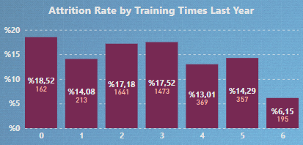

*Recommendation:* Increasing training opportunities to enhance employee skills and job satisfaction may lead to lower attrition rates.

* **Total Working Years**: Employees with more total working years are less likely to leave.

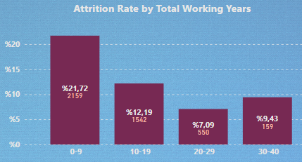

*Recommendation:* Recognizing and rewarding long-term employees can help retain them and reduce attrition rates.

* **Work-Life Balance**: Employees who have bad work-life balance are more likely to leave.

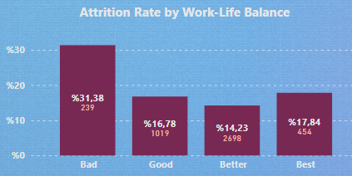

*Recommendation:* Promoting and maintaining a healthy work-life balance can address employees' needs for personal time and flexibility, thereby reducing attrition.

* **Years at Company**: New hires and employees who stay at work for a long time are more likely to leave.

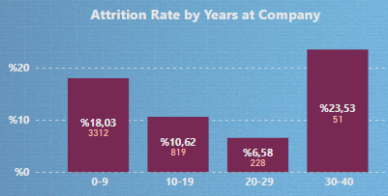

*Recommendation:* Focus may be placed on retaining new employees.

* **Years with Current Manager**: Employees who have worked longer with their current manager are less likely to leave.

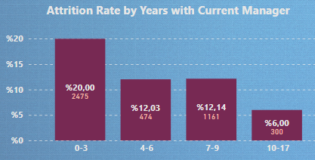

*Recommendation:* Recognizing and rewarding employees who have maintained long-term relationships with their managers can foster loyalty and reduce attrition rates.

## B) Further Analysis

Graphs are combined in this section to obtain meaningful results.

**Age**

* **Monthly Income:** In the 18-24 age group, where the turnover rate is 40%, income does not have a direct effect on leaving a job unless a salary exceeds 160k.

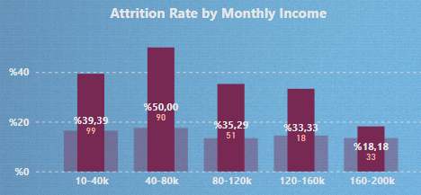 for 18-24 age interval

*Insight:* Increasing income is not a directly valid solution to retain those in the 18-24 age group.

* **Business Travel:** In the 18-24 age group, where the turnover rate is 40%, the turnover rate of those who do not travel is 17%, and for those who travel frequently it is 80%. The turnover rate, which is 20% in the 25-34 age group, is around 30% for those who travel frequently. For other age groups and travel frequencies, turnover rates are relatively low.

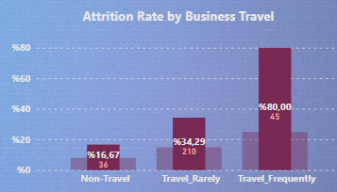 for 18-24 age interval

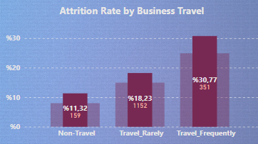 for 25-34 age interval

*Insight:* The travel requirements of the job may be reduced for employees aged 18-34, especially those aged 18-24.

* **Extra/Fewer Working Hours Per Day:** The turnover rate, which is 28% in the 18-29 age group, increases to 47% if overtime is done for more than half an hour, and drops to 18% on average if work is missed for more than half an hour a day.

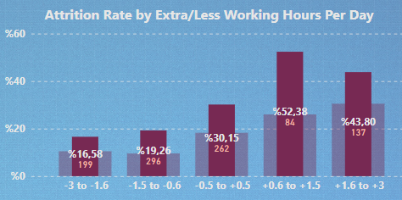 for 18-29 age interval

The turnover rate, which is 10% in the 35-49 age range, increases to approximately 20% for more than half an hour of work, and drops to 6% for more than half an hour of missing work.

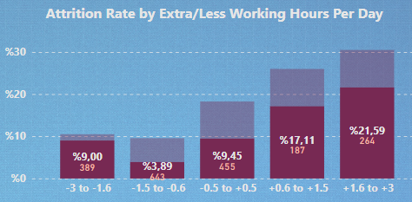 for 35-49 age interval

*Insight:* The age groups most affected by overtime working more than half an hour per day are the 18-29 age range, while the least affected age group is 35-49.

* **Stock Option Level:** The turnover rate, which is 40% in the 18-24 age group, is 55% for stock option level 0 and 22% for stock option level 3.

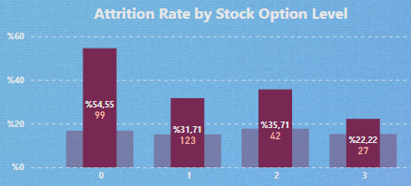 for 18-24 age interval

*Insight:* Stock option level can be increased for employees in the 18-24 age group.

* **Department:** The average turnover rate for the 18-24 and 55-60 age groups is 30%. The turnover groups of these two age groups for the HR department are close to each other and their average is 78%. The small number of employees can be deceiving; but the department's policy for juniors and seniors may be reviewed.

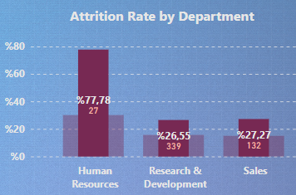 18-24 and 55-60 age intervals

While the turnover rate for those under the age of 35 in the HR department is 44%, this rate is 12.5% ​​for those aged 35-54. Since the high turnover rate of 12 people in the 55-60 age group makes it difficult to make sense of the data, the details of the layoffs of these people can be looked at.

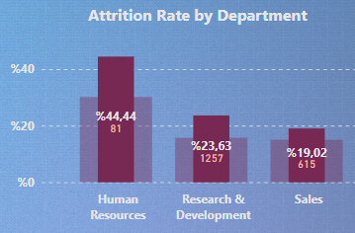 for 18-34 age interval

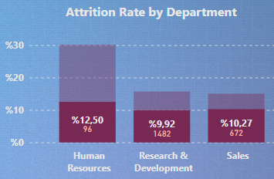 for 35-54 age interval

While the general turnover rate in the 55-60 age group and the general turnover rate of employees in the R&D department is 16%, the average turnover rate of employees in these two groups is around 6%. A more detailed study can be done to understand the reason for this.

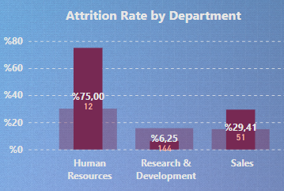 for 55-60 age interval

*Insight:* The attitude towards young people can be improved by checking whether separate policies are followed for groups younger than 35 and older in the HR department. The R&D department's policy on retaining people over the age of 55 can be learned and the general application of this policy can be evaluated.

* **Marital Status:** In general, while the turnover rate of single people is 15% higher than that of divorced people, this difference is 25% for those under 35 years of age.

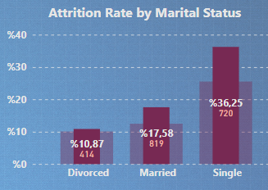 for 18-34 age interval

*Insight:* Preferring married or divorced people when hiring employees under the age of 35 and supporting marriage in the company culture can reduce the turnover rate.

**Marital Status**

* **Income:** While the turnover rate of divorced employees is 10%, this rate is 21% for employees with a salary of 160k+.

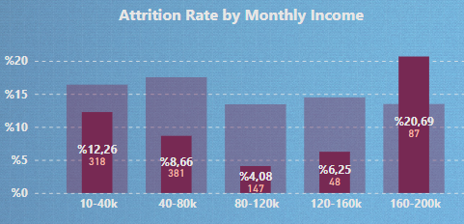 for divorced

*Insight:* It might be worth reviewing whether the company has a different attitude towards divorced employees earning 160k+.

* **Extra/Fewer Working Hours Per Day:** The turnover rate of employees who work at least half an hour extra a day was lowest in married people and highest in single people.

While the rate of quitting work for married couples was 12%, it increased to 20% for working overtime for at least half an hour daily.

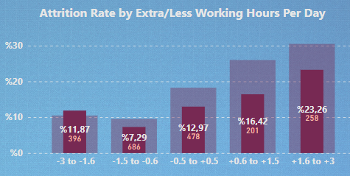 for married

The rate of quitting from work, which was 26% for singles, increased to 47% for those working at least more than half an hour daily.

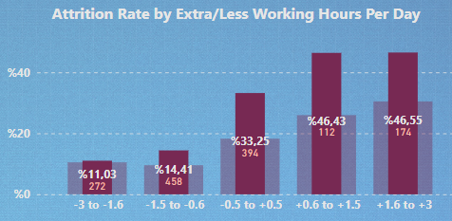 for single

*Insight:* For jobs that require overtime, the fact that the employee is married may be considered an advantage.

* **Education:** It is seen that the turnover rates of married people other than those with a master's degree are lower than the general population, while those with a master's degree are higher.

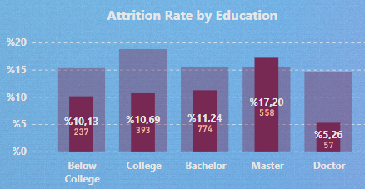 for married

On the contrary, the quit rate of divorced people with a master's degree is quite low.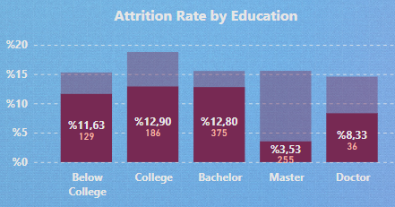 for divorced

*Insight:* It can be evaluated whether the company has a different policy towards divorced master's degree holders or married doctorate holders. This positive policy, if any, can be applied to other groups as well.

* **Stock Optinon Level:** While the general turnover rate of married employees is 12%, the turnover rate of married employees with stock option level 3 is 6%.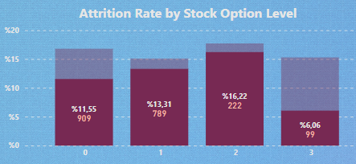 for married

The turnover rate, which is 25% for single employees, is 29% for those with stock level 3.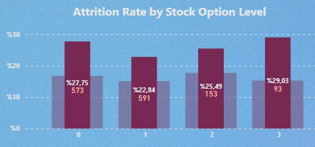 for single

*Insight:* By conducting detailed research on a case-by-case basis, it may be considered to give stock option level 3 to married employees instead of singles.

**Extra/Fewer Working Hours Per Day**

* **Stock Optinon Level:** While the turnover rate for those who work overtime over half an hour is 29%, the rate for this group for stock option level 3 is 57%.

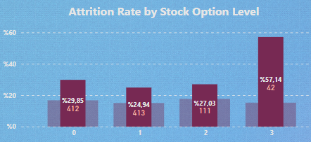 for +0.6 to +3 hours

*Insight:* For overtime employees, different solutions can be considered instead of stock option level 3.

* **Education:** More than half an hour of missing work affected employees in the Bellow College group the most, reducing the turnover rates of both groups here by 12% to 3%. In standard and overtime work, this effect disappears and this group has the highest turnover rate.

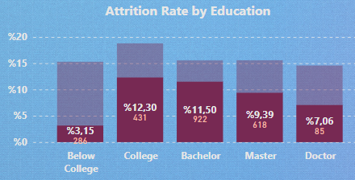 for -3 to -0.6 hours

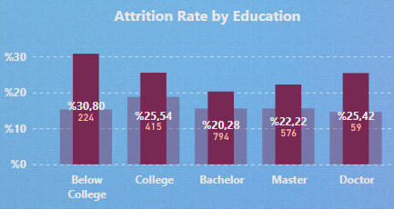 for -0.5 to +3 hours

*Insight:* Employees in the below college group may be considered for working one hour less.

* **Department:** The turnover rate of those who work in HR and work more than 1.5 hours a day on average is 70%. Although the low number of employees may be misleading, precautions can be taken in this regard.

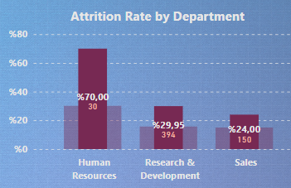 for +1.6 to +3 hours

*Insight:* Overtime in the HR department can be avoided.

# Recommendations Regarding the Data Collection/Analysis Process

* Conducting a survey of employees who quit their jobs about why they left their jobs can shed light on many of the remaining issues and provide healthier insights. For example, an employee who leaves a job can list the reason for leaving the job in certain categories in order of importance. Alternatively, it can be given open-ended answers and then these answers can be categorized by the machine learning model.
* If employees' resignation dates are given, a better prediction of turnover can be made by looking at their performance in the periods 1 month, 3 months, 6 months before this date.
* In_time and out_time tables can be stored differently for efficiency. The employee ID can be in one column, the date showing the day in another column, the employee's check-in time in another column, and the employee's check-out time in the other column.
* For analyzes to be carried out for more than one year, the available data can be stored by adding a time variable to the table. This variable can be optionally seasonal, for example. In this case, more than one EmployeeID value occurring in the table can be referenced to a table that stores employee information and whose key value is this ID.
* Employee management software can be used to collect data by assigning employee and manager surveys periodically and automatically throughout the year. In this way, errors in storing surveys can be reduced. Employees who take part in auditing and storing surveys can transfer their time to more valuable work.
* The employee's company recommendation score can be added to employee surveys. Since this score is one of the most important data showing commitment to the workplace, it can be effective in seeing the employee's satisfaction with the workplace over time.